**Introduction**

In the realm of medical diagnostics, accurate and timely identification of cancerous tissues is critical for effective treatment and patient prognosis. Breast cancer, being one of the most prevalent forms of cancer among women worldwide, necessitates robust and reliable diagnostic tools. Traditional diagnostic methods, while effective, often require invasive procedures and can be time-consuming. The advent of machine learning has paved the way for non-invasive, rapid, and accurate diagnostic methods.

This project focuses on utilizing machine learning techniques to classify breast cancer tumors as either malignant or benign using the Wisconsin Breast Cancer Dataset. By leveraging the capabilities of Support Vector Machines (SVM), we aim to develop a model that can assist medical professionals in making accurate diagnoses based on patient data.

The core objectives of this project include:

1. Data Preprocessing and Feature Engineering
2. Model Selection and Training
3. Hyperparameter Tuning
4. Evaluation and Validation
5. Comparison with Other Models

By implementing these steps, the project seeks to demonstrate the potential of machine learning in transforming breast cancer diagnostics, thereby contributing to the broader field of medical technology and healthcare innovation. The ultimate goal is to create a system that can assist in early detection, improve diagnostic accuracy, and consequently, enhance patient outcomes.

1. Data Preprocessing and Feature Engineering: Ensuring the dataset is clean, standardized, and relevant features are selected to enhance model performance.

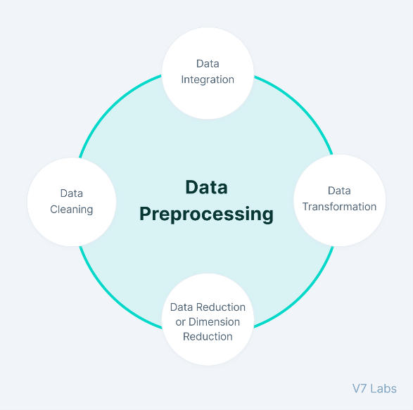

2. Model Selection and Training: Employing SVM with a linear kernel and exploring different kernels to determine the most effective model for this classification task.

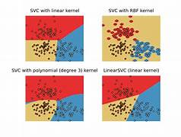

3. Hyperparameter Tuning: Utilizing techniques such as Grid Search to optimize model parameters for better accuracy and generalization.

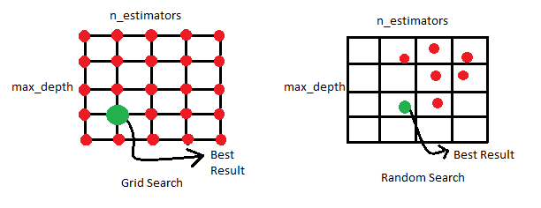

4. Evaluation and Validation: Assessing the model's performance using metrics such as accuracy, precision, recall, and F1-score to ensure reliability and robustness.

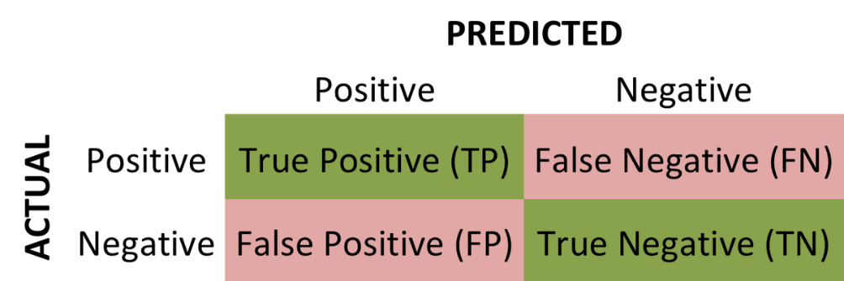

5. Comparison with Other Models: Exploring other machine learning algorithms like K-Nearest Neighbors (KNN) and ensemble methods to benchmark the SVM model's performance.

